# National Maternity and Perinatal Audit

# Draft Quality Improvement plan

Summary

The overarching aim of this quality improvement plan is to articulate the means by which the National Maternity and Perinatal Audit (NMPA) will enable improvements in NHS maternity and neonatal care, in order to optimise outcomes for women and their babies for the current contact period (up to 5 years).

Background

Since 2016 the NMPA has built an expert, multidisciplinary audit team of healthcare professionals, methodologists, analysts and project management staff based within the Clinical Quality department at the RCOG.

Infrastructure to support the audit includes relationships with centralised data providers and Trusts and Boards, an interactive web tool and an integrated Women and Families Involvement group.

As the current providers, the NMPA provides clinically relevant and methodologically robust evaluation of care processes and outcomes in order to identify good practice and feedback areas for improvement in the care of women, birthing people and babies.

Audit Design

The design of the audit for the new contract period from 2023 will build upon and evolve the existing successful strands of the audit by delivering:

* Interactive online data presenting results at national, trust/board and site level. This will include new presentation of data over time, as well as comparisons between trusts/boards.
* ‘State-of-the-nation’ style, short reports presenting selected key findings and recommendations in the accessible style championed by the NMPA Women and Families Group for the ‘lay summaries’.
* A series of ‘snapshot audits’, produced in years 2 and 3 of the contract. While these topics have yet to be agreed there are opportunities for any bespoke data to be collected whilst minimising the data burden on trusts/boards.

Update on relevant audit activity

**Revision of audit measures**

Earlier this year, the NMPA undertook a review of its measures to respond to changes in the digital maternity landscape, advances in clinical maternity care and following landmark events including the COVID-19 pandemic, and publication of reports such as the Ockenden and Kirkup reports.

The aim, process and outcome of this review is reported in a separate paper however, for the purposes of this QI plan, amendments to two measures have been proposed, along with six new measures that were developed with key stakeholder groups including the Clinical Reference Group and Women and Families Involvement Group (acknowledging some of these measure may be unfeasible due to their data quality and completeness).

This exercise to review and refresh NMPA measures – to ensure they are as aligned to the audits overall’s aim as possible - is an important first step in the development of improvement goals.

**Optimising the NMPA’s audit and feedback cycle**

Earlier this year the team also undertook the Self-Assessment Report Card for Audit Programmes (<https://www.hqip.org.uk/wp-content/uploads/2022/04/A-brief-guide-to-effective-audit-and-feedback-March-2022.pdf>), which aims to help leaders of audit programmes identify areas for improvement.

Our findings were reviewed and discussed within meetings with Robbie Foy and Sarah Alderson from the University of Leeds.

Measured using a traffic light scheme, the NMPA scored ‘green’ in most areas (with the caveat sufficient data has not been received to report against all measures beyond April 2019) and the key areas where the NMPA could be a more effective audit have been agreed to be outside the audit’s control (e.g. minimise any delay between data collection and feedback).

Proposed plan to develop improvement goals

The Healthcare Improvement goals for the next phase of the NMPA are a priority for the team and will be a central tenant of the new QI plan.

The goals will build upon the previous work of the NMPA, and be aligned to both the overall aim of the audit and its underlying mechanism of change articulated within its driver diagram (see Appendix one).

The NMPA team have proposed the foundation of these goals will be:

* To reduce adverse outcomes for mothers and babies.
* To improve the number of healthy pregnancies.
* To improve outcomes in disadvantaged groups.
* To identify poor performing services early.
* To explore the feasibility of developing measures to capture the experience of people giving birth.
* To improve data quality and reporting.

In order to ensure the improvement goals deliver on the most urgent and pertinent issues in maternity care, the process for developing these goals can only begin once the most recent data request from NHS England has been received, analysed and validated.

The goals will be developed through workshops with clinicians, data providers, those working at the national level to improve quality, and the Women and Families Involvement Group.

This collaboration with key stakeholder and governance groups will ensure the audit remains integrated within the national maternity landscape and adds value.

As part of this process, we also plan to evaluate how NMPA data is currently used by maternity teams for example, whether the current methods for presenting data supports quality improvement and whether alternatives – aligned to the specific improvement goals - could improve its accessibility.

The intended output of this process is a set of quantifiable improvement goals, to enable progress to be measured and monitored.

Once the improvement goals have been agreed, we will review and revise our methods for stimulating healthcare improvement at national, regional and local level.

At the time of writing, the proposed methods include:

* Relevant and timely data on agreed clinical measures presented both over time and in comparison with other Trusts/ Boards on the NMPA website to support maternity teams to identify local improvement priorities.
* Implementation of appropriate statistical methods and the NMPA outlier policy will ensure poorly performing services are identified as early as possible and supported to improve.
* Bespoke recommendations and targeted advice to Trusts and Boards on how to improve data quality.
* Accessible reports reporting data at the national level, published (at least) annually on the website, including targeted recommendations for improving the quality of care.
* Granular dissemination of findings via webinars, newsletters, podcasts, social media engagement and bespoke events to reach wider audiences.
* An improved ‘quality improvement (QI) area’ of the NMPA website with QI interventions aligned with audit measures and recommendations, case studies on how NMPA data has been used for QI and legacy tools for the ‘snapshot audits’ to allow re-audit.
* Developing the NMPA ‘Family Gateway’ designed and built by women, birthing people and their families to contextualises NMPA data and provides an accessible way to using the audit.

These methods will be reviewed and agreed within a context of developing relationships with regulators, data providers, National Maternity Voices, and all other organisations involved in assessing, assuring and improving maternity services to ensure value is added, duplication is reduced and opportunities for collaboration are identified.

Impact will be evaluated in a large range of areas using an existing impact assessment framework developed within the RCOG (see Appendix two), also working with HQIP on impact assessment visualisations.

Appendix one: The NMPA Driver diagram

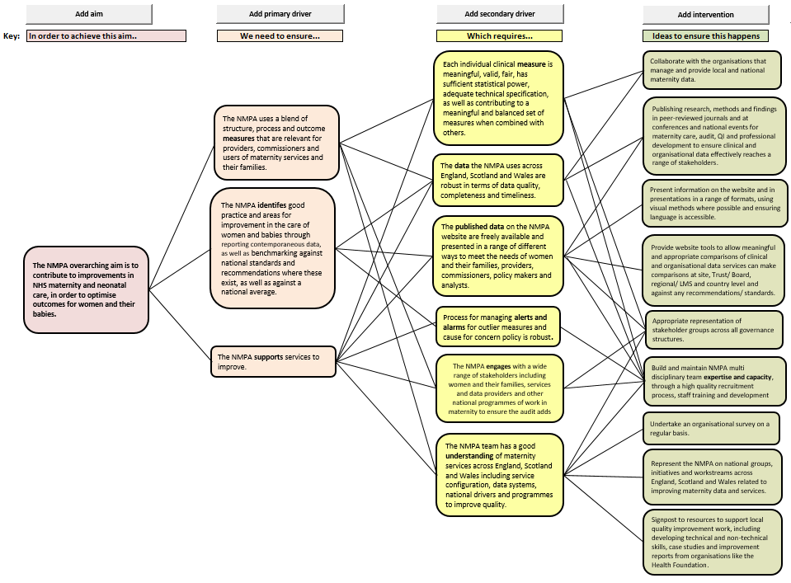

Appendix two: Clinical Quality Framework for measuring impact

|  |  |
| --- | --- |
| **Impact Area- Criteria and** **Suggested Measures/Metrics** | **Impact Evidence** (Please provide as much information as possible including dates/timeframe, sources and links, as appropriate) |
| Impact by numbers:  * Website data incl. number of page visits, number of downloads, number of audio version listens * Social media engagement (Twitter, Facebook, Instagram) * Press coverage * Citations * Altmetric scores of publications * Number of publications |  |
| Impact by influence:  * Where other organisations signpost to our work * Changes to policy or practice have been made as a result of our work * Impact by engagement with external organisations * Press releases from other organisations * Members of the team asked to advise or attend external conferences/ events. |  |
| Impact through PPI and women's engagement:  * Examples of types of PPI and women's engagement * Quotes from women about their experience of being involved * How engagement resulted in changes to the project |  |
| Impact by resourced evaluation and feedback:  * Findings from commissioned evaluations * Findings from any workshops or surveys undertaken * Feedback from funders/ commissioners * Case studies |  |
| Impacts by outputs:  * Type of publications e.g. reports, GTGs, SIPs * Publication of new data or findings e.g. NMPA data, articles in peer review journals * Events |  |